Form Projectidea Towards a cure

www.hersenstichting.nl
T: 070-3604816
E: aanvraag@hersenstichting.nl

Instructions:
- Fill out this form completely.
- Send this form to aanvraag@hersenstichting.nl, stating: OWNG_lastname lead applicant. Please attach your document as an attachment and give it the same title. Also attach the evidence of target group participation as separate attachment(s) to this email. Refer to criteria 2.2 in the grant program for an explanation of the requirements for this target group participation.
- Incomplete forms will not be processed.
- You will receive a message when we have received your application. If you have not received a response from us after 48 hours, please let us know.
- The purpose of submitting a project idea first is to select the most relevant, best fitting, and promising ideas before being asked to further develop them. Submitted project ideas must meet all established criteria and conditions.
- Please note that there is a maximum number of characters per question, including spaces. We encourage you to be as clear and concise as possible. A good idea does not require unnecessary extra explanation. Less is more.
- The last two pages provide space for scientific references and two figures.
- Track changes and comments cannot be used in this form. If needed for preparation purposes, you can find a draft version that can be edited on the subsidy page. The draft document will not be accepted as a submission.
- The project ideas will be evaluated by our Advisory Board of Experts by Experience and our Advisory Board of Science & Innovation. There can be no objection to the outcome of the selection.
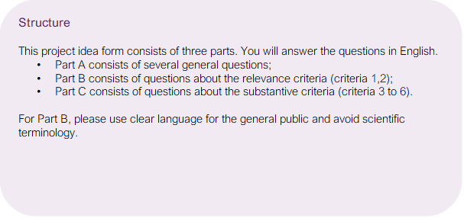

Part A – General

1. Applicants
The complete team can be described in question 3.

Applicant 1 (lead)
Title and Name | ​​Click or tap to enter text.​
Position | ​​Click or tap to enter text.​
Organisation | ​​Click or tap to enter text.​
Afdeling | ​​Click or tap to enter text.​
Telephone | ​​Click or tap to enter text.​
E-mail | ​​Click or tap to enter text.​

Applicant 2
Title and Name | ​​Click or tap to enter text.​
Position | ​​Click or tap to enter text.​
Organisation | ​​Click or tap to enter text.​
Afdeling | ​​Click or tap to enter text.​
Telephone | ​​Click or tap to enter text.​
E-mail | ​​Click or tap to enter text.​

Part A - General

2. Title and summary
- Formulate a title that clearly indicates which brain disorder(s) the research is targeting and what the project aims to achieve.

Example: Using natulizumab as an Inhibitor of Inflammatory Response in Multiple Sclerosis
Example: Developing a Lentiviral Gene Therapy to Slow Disease Progression in Hunter Syndrome
​​ ​ (max 80 characters)

- Write a summary that lists the following points:
• Who is the target group and which brain disorder(s) does it concern?
• What problem does the target group experience and what is the intended solution?
• What is the research question and what are the intended outcomes?
(max 2500 characters)

Part A – General

3. Team
- Identify all team members (including advisors and individuals with lived experience) and their roles. What expertise does each team member bring, and why is this expertise necessary?

(max 2500 characters)

Part B – Relevance
This section consists of questions related to the relevance criteria, which are detailed in the subsidy program. Need-driven solutions that are translated into practical healthcare are the main focus of this subsidy program.

It is intended that the needs of the target group have been identified by lay experts, and the proposed solution aligns with those needs. The evidence for this should be submitted as a separate attachment along with this form. The requirements for this evidence are described in detail in criteria 2.2 of the funding program.

This section should be written in English and be easily understood by the general public, while avoiding scientific terminology.

4. Relevance
- Who is the target group and what problem do they experience?
(max 1500 characters)

- What is the ultimate solution that this project idea will contribute to?
(max 1500 characters)

- What is the added value of the intended solution according to the target group?
(max 1500 characters)

- How is the target group involved in the development of this project idea and how is the input collected from the target group incorporated?
(max 2500 characters)

Part C – Content
This section consists of questions that relate to the substantive criteria. These criteria are elaborated in the grant program. The requirements are detailed in section 2.2.
5. Content
- Describe how your project idea is a step towards the ultimate goal of a new therapeutic treatment in clinical practice.
- What step is taken with this project?
- What further steps are needed afterwards?

(max 2000 characters)
- How is the project idea disease-modifying (delaying/stopping/curing the disease)? How does it intervene in the disease mechanism, through which target? What evidence is already available?
Note: Reducing symptoms or improving functioning while the disease course continues is not considered as disease modification within this subsidy program.
(max 3000 characters)

Part C – Content

6. Study design and plan of approach.
- Provide a description of:
- the objective(s)
- the hypothesis(es)
- the research strategy (including the research plan, methods, outcome measures, analyses)
- the expected results
- the timeline
(max 5000 characters)

References
Please provide the literary references here.

Figures
Please upload any figures here:
- There is room for two figures;
- Any textual explanation is added within the figure;
- The size of the figure can be adjusted using the cursor.
​​​
​​​

